User Guide

# 



*All information was accurate at time of writing.*

## Using the homepage.

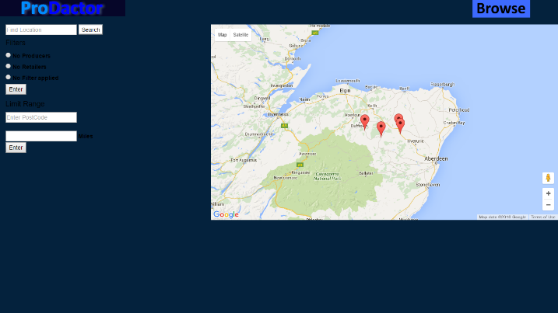

Figure :The main page of ProDactor

The homepage is where you come first when you visit the site. On the top you will find the search bar, the search bar’s purpose is to search the database for further locations. You can access it by entering a search query into the bar and pressing the search button. Below are filters. These can be used to filter out your search or alternatively be used to filter out the maps’ markers. To filter out producers, use the no producers radio button, To filter out retailers, use the no retailers radio button. To bring everything back, use the no filter applied radio button.

The last of the forms is the range limiter. The range limiter is used to limit the range from outside a certain location. To use it you will need to enter a postcode or any valid address. After doing so, you will be required to specify how far you want to limit in miles. After pressing the button depending how far the distance was the markers will either disappear or remain.

The map uses google maps and functions very much the same. The map is scrollable and can be zoomed in and out by using the + - buttons. To move the map, hold the map and drag it to move it around. The map at the moment contains 4 markers. These markers can be clicked on to be opened. When a marker is opened an info window will be visible. This will contain the name of the location, a brief description and 2 links to their information page and directions. You can close these info windows by clicking the black cross on the top right or alternatively by opening a new marker.

## Info page.

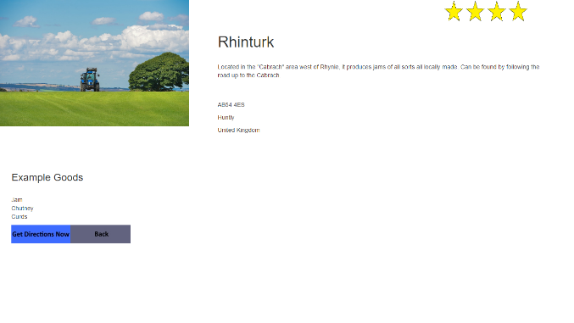

Figure :Rhinturks info page

The info pages contain information about the locations such as a full address and a link to directions. There is the information such as description and example of what is for sale. Then there is 2 buttons. The back button takes you back to the last page you visited and the directions button takes you to the directions page where you can get directions. Each location has its unique page. To access the page you can either use the link in the home page, go into the browse page or search a location.

## Directions page.

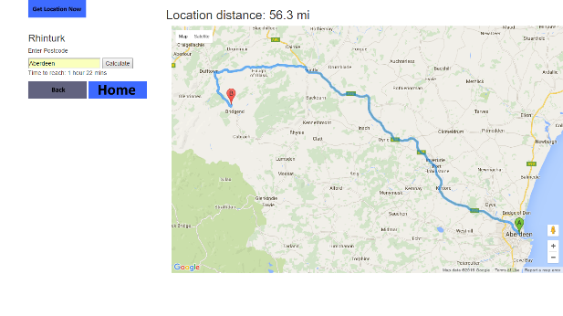The directions page will give you directions to a location. It will also tell you distance to the location and how long it will take to get there. Assuming there isn’t any major barriers such as huge swaths of ocean, the directions will tell how to get to the location by car. To use the directions page you first must enter an address, then press the calculate button. A route will then be generated with an accompanying distance to location and a time to get there. Please note that the route is restricted by how practical it is for a car to reach there so sadly getting cross continental routes from America to Europe for example will probably be impossible due to the Atlantic Ocean being in the way. It is however possible to generate a route from Moscow. Sometimes you will be required to specify the country. An example of this happening would be entering “Birmingham, uk” instead of just Birmingham.

Figure : Rhinturk's directions page with a route generated

To ensure you get correct routes, please stick to only using European routes.

It is also possible to generate a route using the get location now button. This skips entering a postcode and gets your geolocation from your web browser. Please note that this is based on your routers’ ip address as well. So rare anomalies such as generating a route from where the router’s data server is hosted can happen.

## Search page.

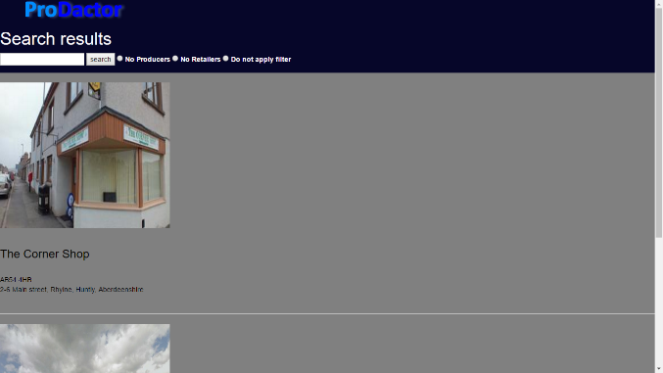The search page will let you query a search into the database to bring up locations. To search a location, use the search bar in the homepage or in the browse page. After entering a search query, the search page will return the results in the grey section of the page. The returned results will show an image, the name of the location and the address. To access the result, click on the image and it will take you to the info page. You can also apply a filter to filter out producers and retailers. To do this, use the radio buttons on either the home page’s left side of the page or on the Browse page’s upper right side. If no results have been found, the search page will simply display “found 0 results”.

Figure : A search page with 2 results

## Browse page

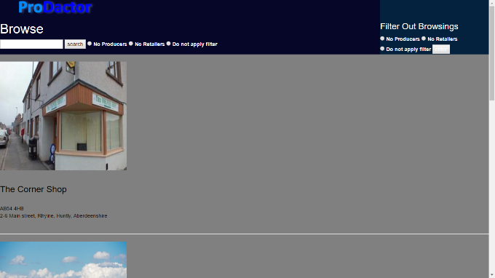The Browse page is similar to the Search page, with the key difference is that all locations can be found. The browse page has a search bar which allows you to search the database like in the homepage. This is located on the upper-left. On the right there is filters, these filters will be used when searching. On the right side of the page is another set of filters. These filters can be used to filter out the browsing but not search. To access a location’s info page from the browse page. Click on the location’s image.

The browse page